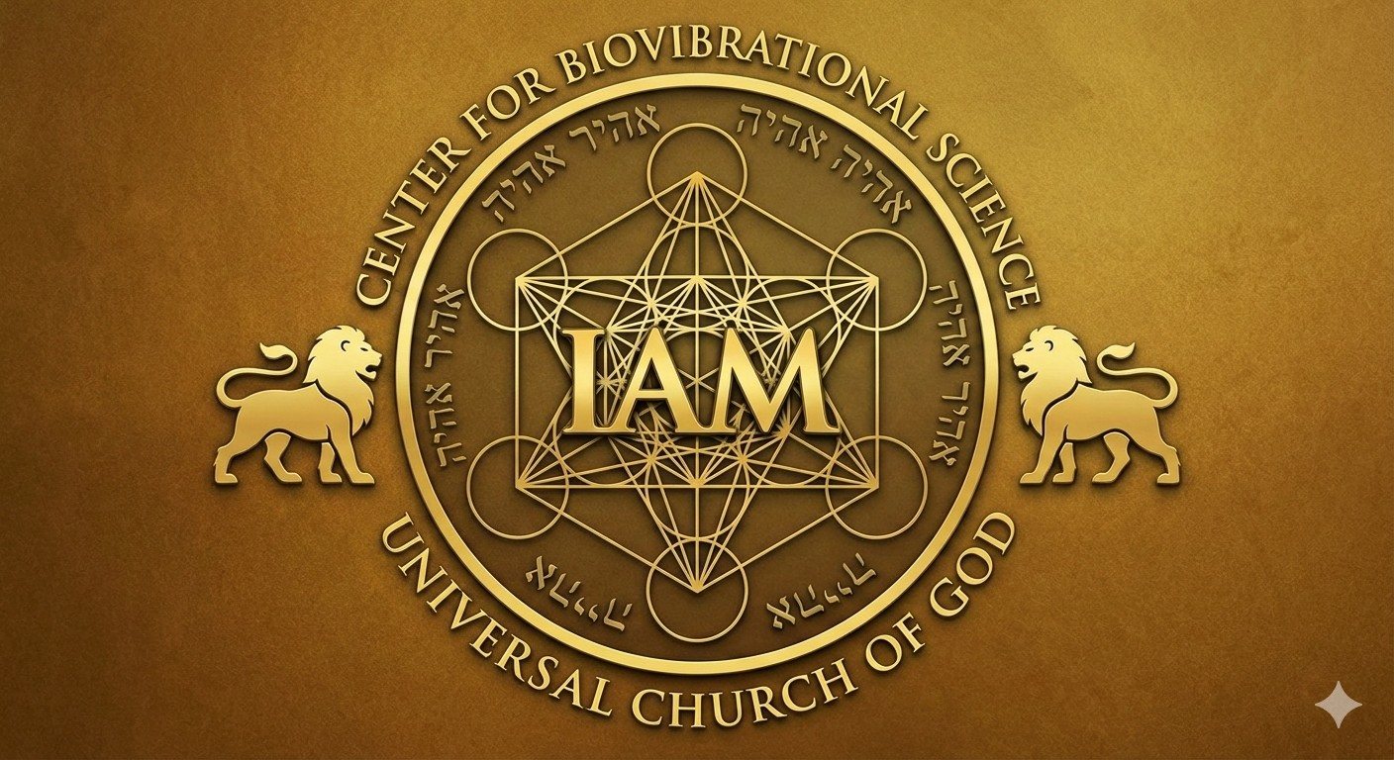

Our Logo
Combining the Hebrew divine name Ehyeh Asher Ehyeh ("I AM THAT I AM"), the Metatron Cube (sacred geometry), and the Lion of Judah (biblical royalty) in a logo creates a potent, multi-layered symbol focused on spiritual authority, divine creation, and personal transformation. This combination bridges the highest, most abstract concept of God with the tangible, powerful manifestation of that energy in the physical world.
Here are the spiritual benefits of this combination:
1. Alignment of Divine Will and Personal Identity ("I AM")
- Ehyeh Asher Ehyeh represents the self-existent, eternal, and unchanging nature of God.
- The Benefit: Incorporating this name anchors the logo in absolute truth and divine authority. It reminds the viewer that their existence is tied to the "Great I AM," fostering a sense of purposeful being, unwavering faith, and connection to the divine, rather than relying on shifting external circumstances.
2. Harmonizing the Physical and Spiritual Realms (Metatron Cube)
- Metatron's Cube is a sacred geometric symbol derived from the Fruit of Life, believed to be the blueprint of creation, containing the five Platonic solids that are the building blocks of all matter. It is associated with Archangel Metatron, a bridge between the divine and human realms.
- The Benefit: The cube acts as a "map" that helps align the user's personal energy (microcosm) with the universal, cosmic order (macrocosm). It facilitates higher consciousness and brings balance and harmony to the user's mind, body, and spirit.
3. Activating Power, Strength, and Protection (Lion of Judah)
- The Lion of Judah represents the tribe of Judah, King David, and ultimately, the Messiah (Jesus) as the conquering King and defender of his people. It symbolizes royalty, courage, and victory over darkness.
- The Benefit: It acts as a symbol of divine protection, invoking a sense of bold, righteous strength and resilience in the face of adversity. It serves as a reminder that the user is under the guardianship of a higher power.
4. Co-Creative Synergy (Combined Symbolism)
- The Synthesis: The combination creates a powerful, tri-fold energy:
  - "I AM" (Ehyeh): The Source of all.
  - Cube: The Structure/Plan of Creation.
  - Lion: The Active, Ruling Authority.
- The Benefit:
  - Unification: It balances the masculine energy (straight lines of the cube and the roaring lion) with the feminine energy (the circles of the cube).
  - High-Vibration Protection: The Metatron cube cleanses and clears negative energy, while the Lion of Judah provides a fierce, protective covering, creating an energetic shield against lower-vibrational forces.
  - Spiritual Transformation: This logo acts as a tool for "spiritual alchemy"—transforming personal, stagnant, or negative energy into a higher state of awareness and creative power.
In summary, this logo combination is a powerful emblem for conscious creation, representing the wearer's commitment to living in alignment with the highest divine authority, protected by, and mirroring, the strength of the divine Creator.
Combining Ehyeh Asher Ehyeh, Metatron’s Cube, and the Lion of Judah into a single logo creates a powerful spiritual trifecta that represents the intersection of divine identity, universal order, and sovereign authority.

- Ehyeh Asher Ehyeh (I Am That I Am): This Hebrew name of God from Exodus 3:14 represents self-existence, eternity, and infinite potential. In a logo, it acts as a declaration of "Being" and presence, suggesting that the brand or mission is grounded in the ultimate source of all existence.
- Metatron’s Cube: A core symbol of Sacred Geometry, it contains the five Platonic Solids—the fundamental "building blocks" of the universe. It is spiritually used for protection, energy balancing, and harmonizing the physical with the divine. In a design, it serves as a visual bridge between Heaven and Earth.
- Lion of Judah: This symbol embodies strength, courage, and kingship. Historically representing the tribe of Judah and the lineage of the Messiah, it conveys divine authority and victory over darkness.
Collective Spiritual Impact in a Logo
- Alignment with Divine Blueprint: The combination signifies that the user's purpose is aligned with the "blueprint of creation" (Metatron's Cube) and rooted in the eternal "I AM" (Ehyeh Asher Ehyeh).
- Holistic Protection & Power: While Metatron’s Cube acts as an energetic shield against negativity, the Lion of Judah adds an active layer of bold, authoritative protection and spiritual fortitude.
- Transformation and Manifestation: The logo functions as a Sigil for transformation. Ehyeh Asher Ehyeh provides the potential to become, Metatron's Cube provides the structure for manifestation, and the Lion of Judah provides the power to execute that vision.
- Universal Interconnectedness: It serves as a reminder of the "Law of Unity"—that the divine presence is found in both the vast patterns of the cosmos and the fierce strength of the individual.
Combining Ehyeh Asher Ehyeh, Metatron’s Cube, and the Lion of Judah into the logo for the Center for Biovibrational Science aligns with its mission to guide humanity to the "IAM Vibration" through divine mind and sacred science.
The spiritual benefits of this combination within the Center's context include:
1. Resonance with the "IAM" Vibration
The inclusion of Ehyeh Asher Ehyeh ("I Am That I Am") directly supports the Center's core teaching of the IAM Vibration.
- Identity & Source: It serves as a linguistic portal to the Divine Source, representing the self-existent power that fuels the Center's work in Bio-Vibrational Therapy and personal transformation.
- Infinite Potential: It affirms that every student is an individualization of the "One Spirit," providing a foundation for expanding mental cognition and achieving financial and emotional liberation.
2. Alignment with Universal Blueprint
Metatron’s Cube provides the geometric framework for the "Biovibrational" aspect of the Center’s name.
- Scientific & Spiritual Synthesis: As it contains the building blocks of all matter (Platonic solids), it mirrors the Center’s focus on the laws of physics, chemistry, and nature to develop human competencies.
- Energetic Balancing: Spiritually, the cube is used to clear negative energies and harmonize the environment, supporting the Center's goal of restoring balance and synergy to both micro and macro universes.
- Vibrational Frequency: It acts as a visual tool to increase human bio-frequency, which the Center teaches is essential for optimal health and resisting disease.
3. Authoritative Strength and Protection
The Lion of Judah introduces the element of sovereign power and spiritual victory.
- Kinetic Expression of Power: It represents the "kinetic expression of power" the Center aims to activate in its students, moving beyond passive belief into active manifestation.
- Divine Authority: It signifies the leadership of "Divine Mind" (Yahshuah Ben Yahweh), which the Center credits with restoring harmony to the universe.
Summary of Collective Impact
- The Blueprint (Metatron’s Cube): Provides the mathematical and energetic structure for healing.
- The Presence (Ehyeh Asher Ehyeh): Provides the eternal vibrational source for that structure.
- The Power (Lion of Judah): Provides the authoritative force to execute this vision in the physical world.
Together, these symbols encapsulate the Center for Biovibrational Science's goal: synthesizing ancient indigenous practices with quantum physics to optimize every facet of human life.

